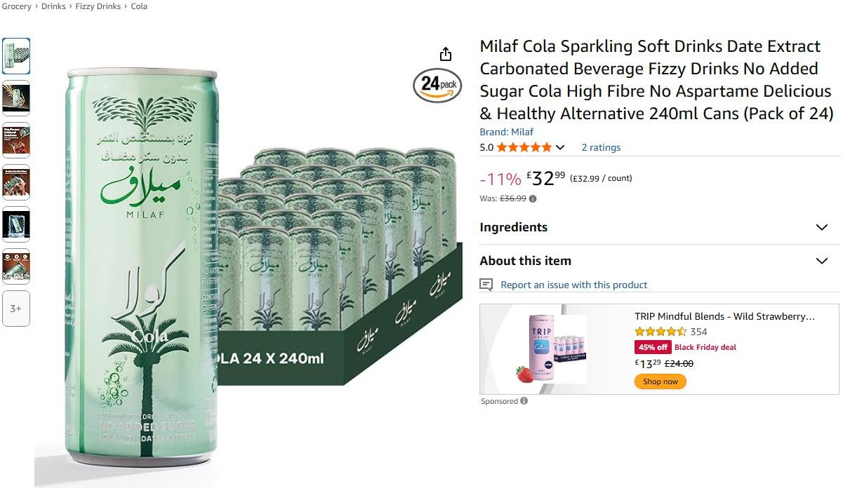
112,000pcs x Milaf Cola Sparkling Soft Drinks …………… Selling at £1.37 Cost is 0.16 GBP
50% of the stock is Feb Dated and the rest is Exp March 2026

